[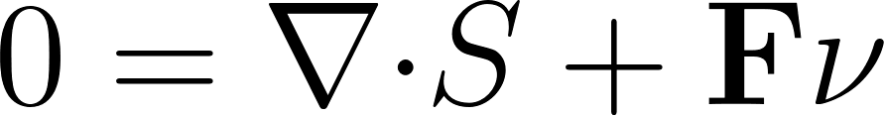](https://www.codecogs.com/eqnedit.php?latex=0%3D%5Cnabla%20%7B%5Ccdot%20S%7D%20%2B%20%5Ctextbf%7BF%7D%5Cnu#0)

[](https://www.codecogs.com/eqnedit.php?latex=S%3DS_%7Binel%7D%20%2B%20S_%7Bel%7D#0)

[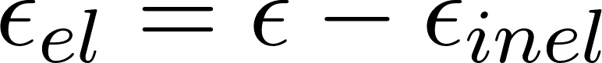](https://www.codecogs.com/eqnedit.php?latex=%5Cepsilon_%7Bel%7D%3D%5Cepsilon-%5Cepsilon_%7Binel%7D#0)

[](https://www.codecogs.com/eqnedit.php?latex=S_%7Bel%7D%3D%5Ctextbf%7BC%7D%3A%5Cepsilon_%7Bel%7D#0)

[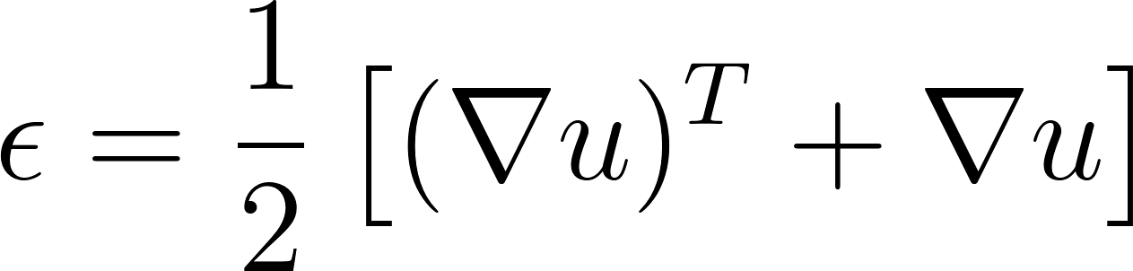](https://www.codecogs.com/eqnedit.php?latex=%5Cepsilon%3D%5Cfrac%7B1%7D%7B2%7D%5Cleft%5B%20(%5Cnabla%20u)%5E%7BT%7D%20%2B%5Cnabla%20u%5Cright%5D#0)

[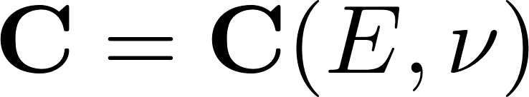](https://www.codecogs.com/eqnedit.php?latex=%5Ctextbf%7BC%7D%3D%5Ctextbf%7BC%7D(E%2C%5Cnu)#0)

[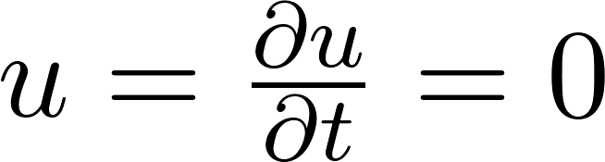](https://www.codecogs.com/eqnedit.php?latex=u%3D%5Cfrac%7B%5Cpartial%20u%7D%7B%5Cpartial%20t%7D%3D0#0)

[](https://www.codecogs.com/eqnedit.php?latex=u%3D0#0)

[](https://www.codecogs.com/eqnedit.php?latex=u%20%5Ccdot%20n%20%3D%200#0)

[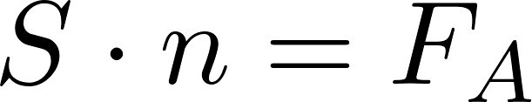](https://www.codecogs.com/eqnedit.php?latex=S%20%5Ccdot%20n%3DF_A#0)  
[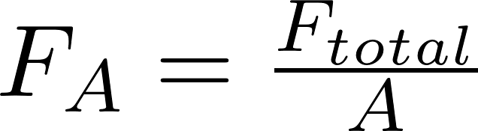](https://www.codecogs.com/eqnedit.php?latex=F_A%20%3D%20%5Cfrac%7BF_%7Btotal%7D%7D%7BA%7D#0)

[](https://www.codecogs.com/eqnedit.php?latex=F_%7Btotal%7D%3D-7.08%20%5Ccdot%2010%5E%7B-8%7D%20N%20%5Ctext%7B%20%20%7D%5Chat%7Bz%7D%20#0)

[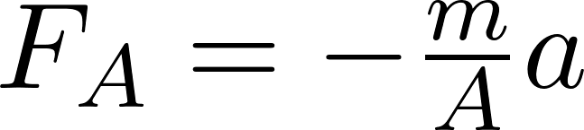](https://www.codecogs.com/eqnedit.php?latex=F_A%20%3D%20-%20%5Cfrac%7Bm%7D%7BA%7D%20a#0)

[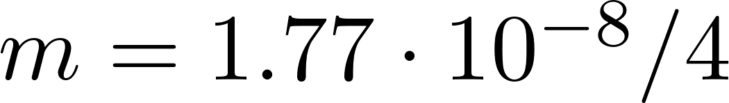](https://www.codecogs.com/eqnedit.php?latex=m%3D1.77%20%5Ccdot%2010%5E%7B-8%7D%2F4#0)

[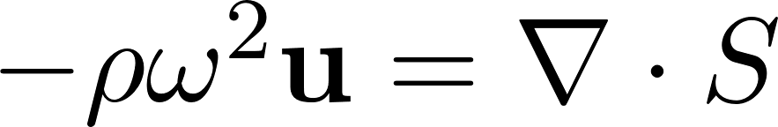](https://www.codecogs.com/eqnedit.php?latex=-%5Crho%20%5Comega%5E2%20%5Ctextbf%7Bu%7D%20%3D%20%5Cnabla%20%5Ccdot%20S#0)

[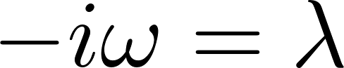](https://www.codecogs.com/eqnedit.php?latex=-i%20%5Comega%20%3D%20%5Clambda#0)